MODULE 1 & 2

1. Consider a case, a folder has multiple files and how would copy it to destination machine path (Try using scp, cp options in Linux)
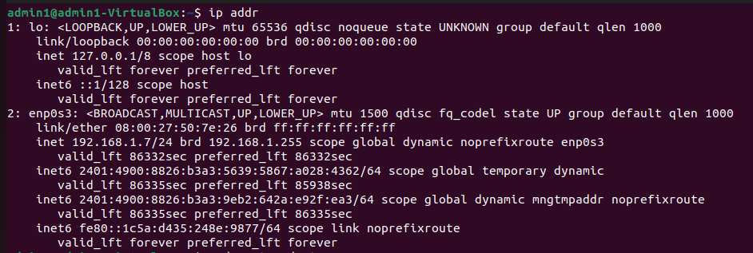
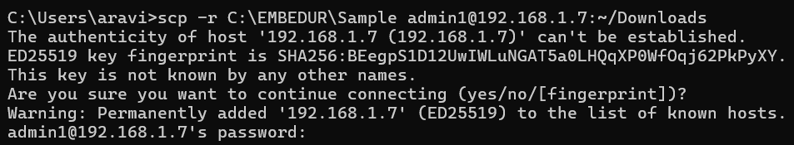
Q2. Host a FTP and SFTP server and try PUT and GET operations.
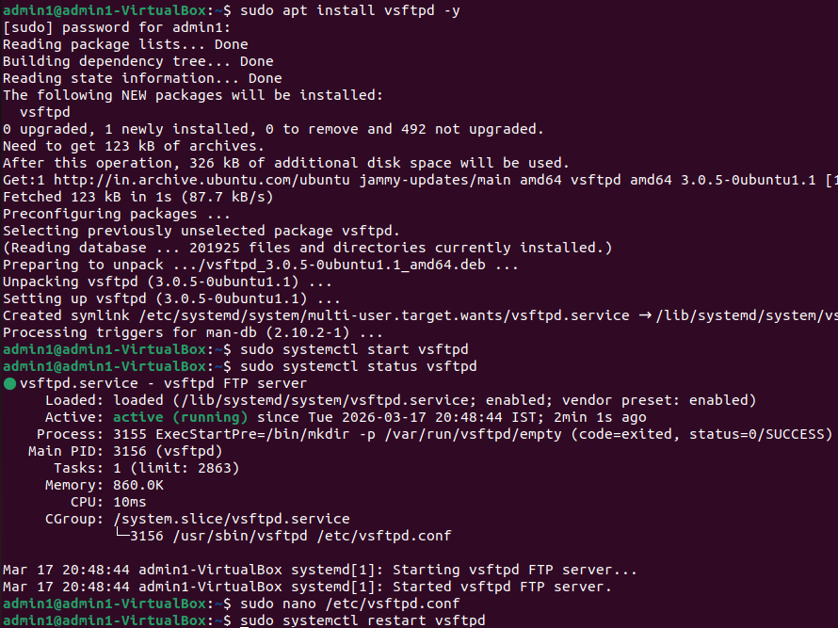
local_enable=YES
write_enable=YES
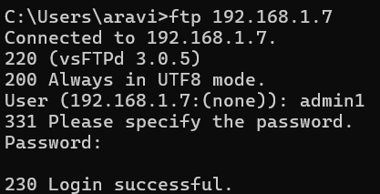
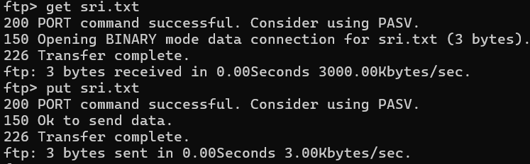
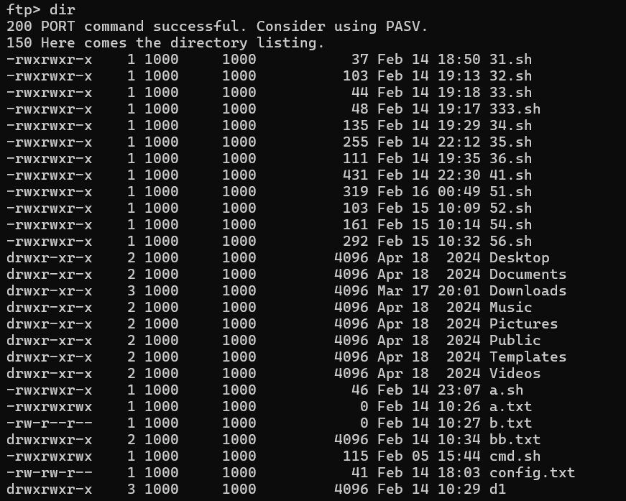
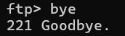
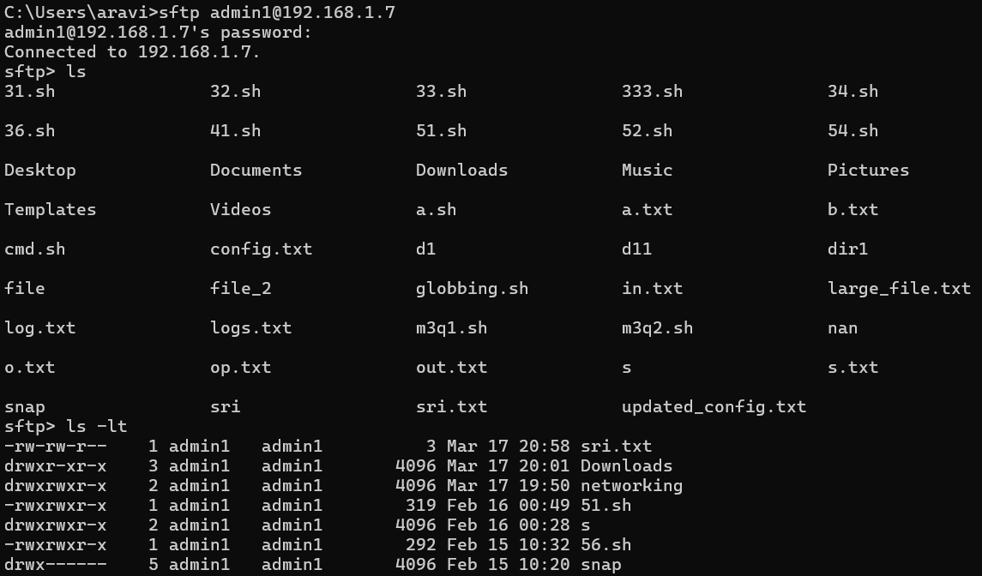
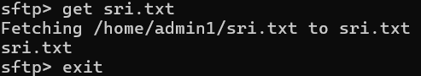

3. Explore with Wireshark/TCP-dump/cisco packet tracer tools and learn about packets filters
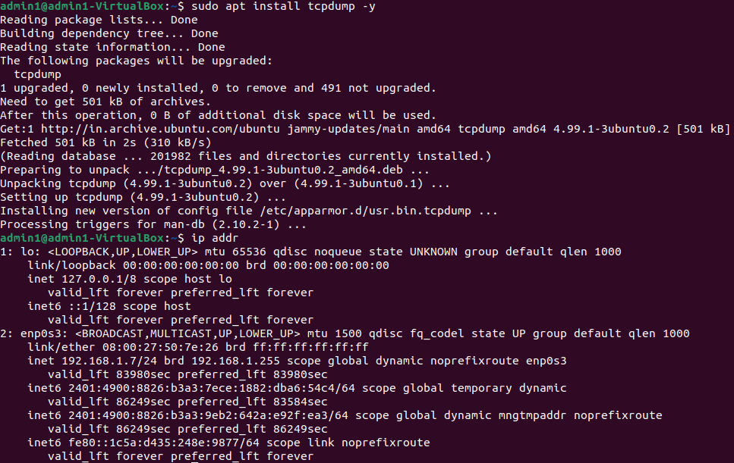
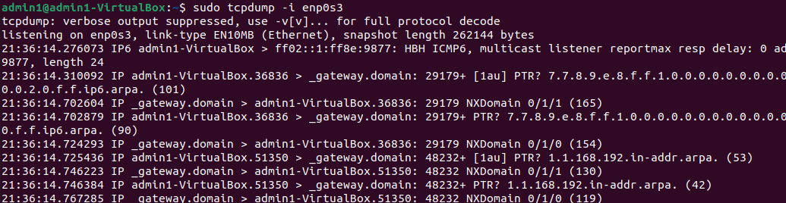
By IP → host 192.168.1.4
By Port → port 80
By Protocol → icmp, tcp, udp
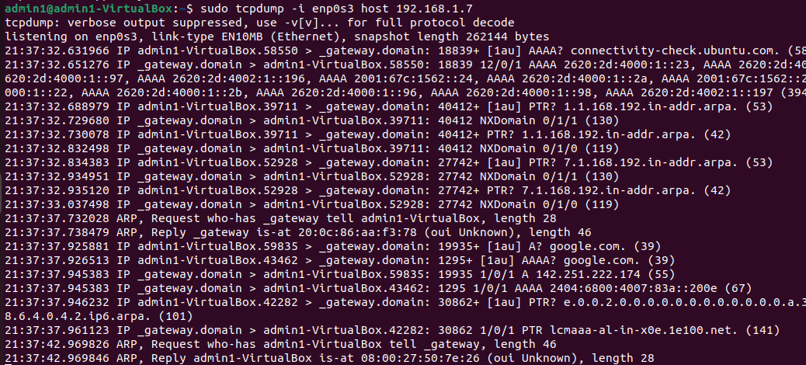
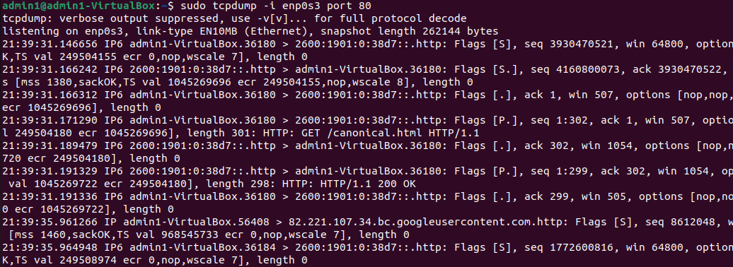
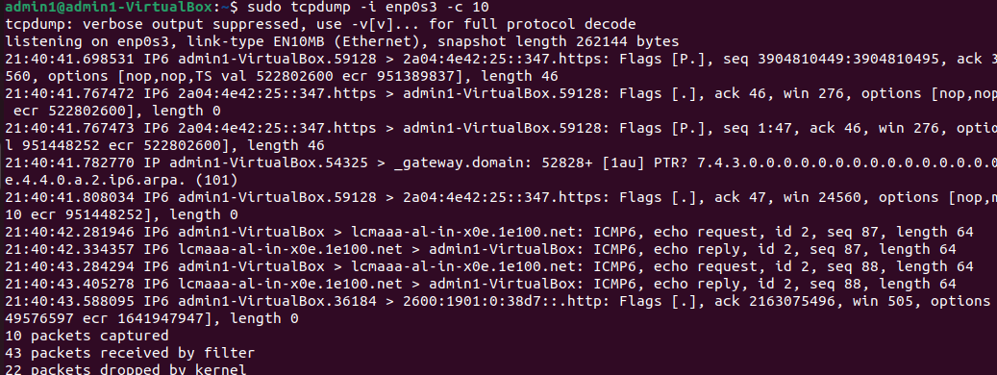

4. Understand Linux utility commands like - ping, arp (Understand each params from ifconfig output)
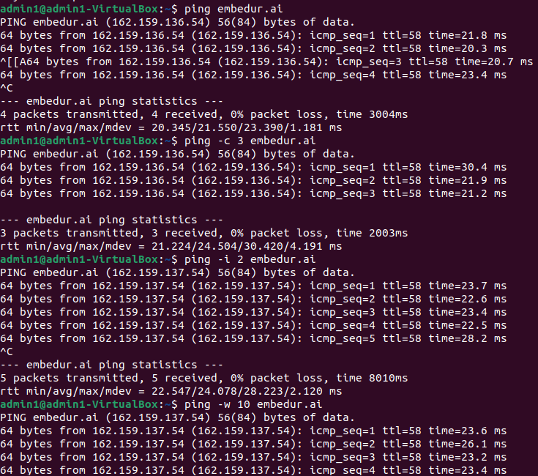
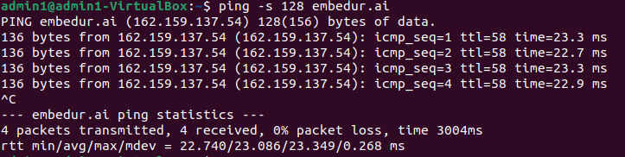
Ping – checks connectivity
-c packets
-i time interval
-w set timeout
-s packet size
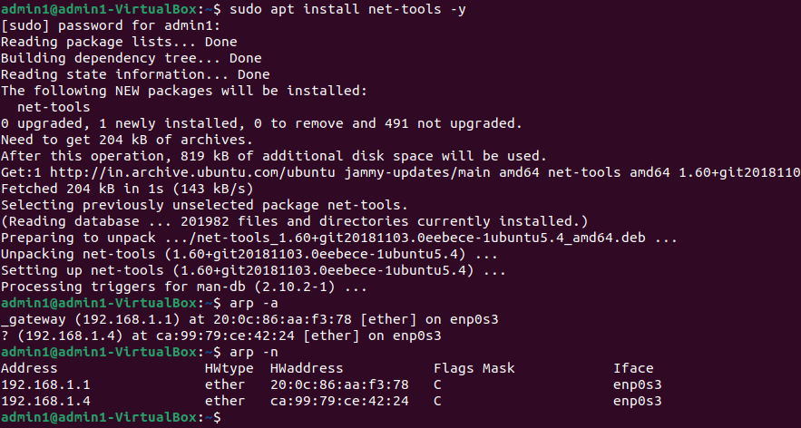
-a arp table
-n numerical output
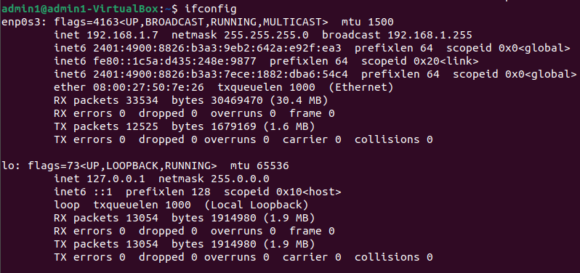
inet → IP address
netmask → subnet mask
ether → MAC address
mtu → max packet size
RX/TX → data received/sent
5. Understand what happens if a duplicate IPs configured in a network.
Duplicate IP address conflict is a condition where 2 devices have the same IP addresses assigned to them .
Duplicate IP conflicts arise in 2 situations mostly:
- When two devices are statically (manually) assigned the same IP
- When the same IP which is manually assigned is also there in the DHCP pool, so when a device boots and gets the same IP from the DHCP pool duplicate IP conflict occurs
- The devices might have network connectivity issues and the network traffic will get disturbed and the routers will disable one of the devices
- It also causes a ARP table instability. Since ARP maps IP Addresses to MAC address, conflicting devices keep updating their MAC in the ARP table causing incorrect data routing. And thus this can lead to sending packets to a wrong device or dropped packets.
Some ways to detect and prevent duplicate IP addresses are:
- Admins can check ARP tables to identify duplicate entries.
- DHCP server logs can also detect conflicts.
- Re-assigning a unique IP to static IP devices is also one solution.
- In larger networks, Dynamic ARP Inspection (DAI) can be enabled to prevent unauthorized ARP modifications, reducing the risk of conflicts and spoofing attacks.
Q6. Understand how to access remote system using (VNC viewer, Anydesk,Teamviewer)
VNC Viewer:
- On the remote computer, install the VNC server and on the local device install the VNC Viewer.
- Setup the VNC server on the remote computer by providing password for access.
- Connect using your RealVNC account and select the remote computer to connect. Use the password to authenticate.
- It has a criteria that it should be connected to a same lan or wifi network
- But it is less secure since no encryption is done, only the password is there to protect data.
Anydesk:
- Download and install Anydesk on both the computers.
- Share the access code shown on the remote computer to the local computer user.
- Enter the access code on the local machine and accept the connection request on the remote computer to establish control of the remote computer.
- No need of common LAN, works on internet
- It uses AES (more secured than VNC)
Teamviewer:
- Install Teamviewer on both the remote and local devices.
- Share the ID and the password of the remote device to the local machine user.
- Enter the ID and authenticate using the password to establish control and start the session.
Remote Desktop Connection:
- Built in tool in some windows edition
- Very much secured and configured
- Need a common lan or wifi

Q7. Check if default gateway is reachable or not and understand about default gateways
- The default gateway is the router or network device that connects your computer to other networks, including the internet. It acts as a bridge between your local network (LAN) and the outside world (WAN/Internet).

8. Check iwconfig/ifconfig to understand in detail about network interfaces (check about interface speed, MTU and other parameters)
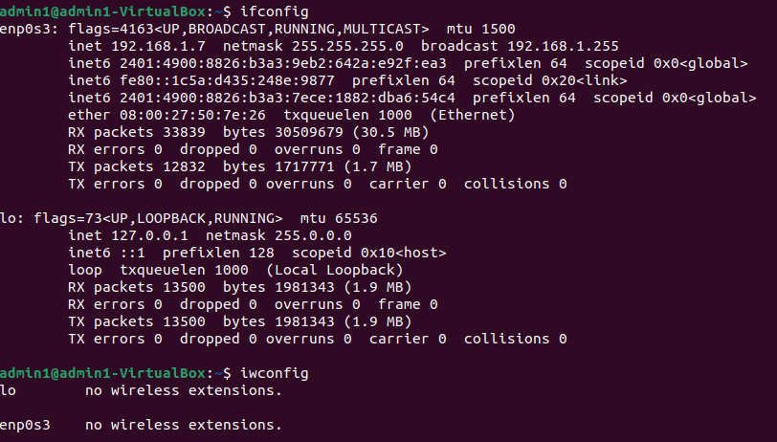

9. Log in to your home router's web interface (usually at 192.168.1.1 or 192.168.0.1) and check the connected devices list.
By accessing the home router's web interface with a username and password, users can review various network statistics. The interface displays details such as the number of connected devices along with their names. Additionally, under the statistics tab, users can view each device's IP address and the amount of bandwidth it has consumed.
Q10. Explain how DHCP server assigns IP addresses to devices in your network
A DHCP server automatically assigns IP addresses and other network configurations to devices over a network. This eliminates the need for a manual IP assignment and ensure there is no conflicts regarding the same. Whenever a device wants to connect to a network, it undergoes DORA process to get IP address using DHCP:
DORA Process :
- Discover - if a client device has no IP address yet, it sends a DHCP discover message as a broadcast to find a DHCP server. This message is sent to all available DHCP servers in the network.
- Offer - dhcp server responds with a ip address along with subnet mask ,duration of ip that device can hold (lease time) , gateway ip through DHCPOFFER message.
- Request - the device will accept the ip provided from the dhcp server, and it will notify all the other dhcp servers that this particular ip is assigned to that device .Other dhcp servers will not use that to another device untill this device duration ends through DHCPREQUEST message.
- Acknowledgement - The DHCP confirms the assignment by sending a DHCP acknowledgement message.
The assigned IP is temporary and has a lease time. Before it expires the client sends a DHCP request again to renew the lease.If the lease expires without renewal, the IP is returned to the pool for other devices.

